Summer School
in Philosophy 2018

University of Cologne
August 6 - 10, 2018

Jennifer Lackey
(Northwestern University)

New Trends in
Applied Epistemology

Organization: Thomas Grundmann
http://summerschoolphilosophy.uni-koeln.de/

Kindly supported by:
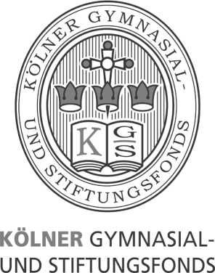

Monday, August 6

3:00 Opening

3:15 Lecture
Group Lies
Jennifer Lackey

break

7:00 Public Lecture:
Experts and Peer Disagreement
Jennifer Lackey
-------------
9:00 Reception

Tuesday, August 7

11:00 Critical comment:
In Defense of Experts as Authorities
Thomas Grundmann (Cologne)

lunch

1:30 Lecture:
Group Belief
Jennifer Lackey

break

3:15 Critical comment:
Selfless Assertions and Genuine Assertions
Gregorz Gaszczyk (Groningen)

break

4:30 Critical comment:
Group assertion and group silencing
Leo Townsend (Vienna)

Wednesday, August 8 (Day Off)

Thursday, August 9
11:00 Lecture
Group justification: inflationary views
Jennifer Lackey

lunch

2:15 Critical comment:
Group Knowledge and Group Agency
Keith Harris (Missouri)

break

3:30 Lecture:
Group justification: deflationary views
Jennifer lackey

break

5:15 Critical comment:
Group Belief, Deliberation, and Justification
Molly O’Rourke-Friel (Amherst)
-

Friday, August 10

11:00 Critical comment:
How Philosophers Learn From Each Other
Ethan Landes (St. Andrews)

lunch

2:00 Lecture:
False Confessions and Testimonial Injustice
Jennifer Lackey
---
7:30 Farewell Dinner

